Sochi –  the resort Capital  of Russia | - Sochi is the ideal choice for you  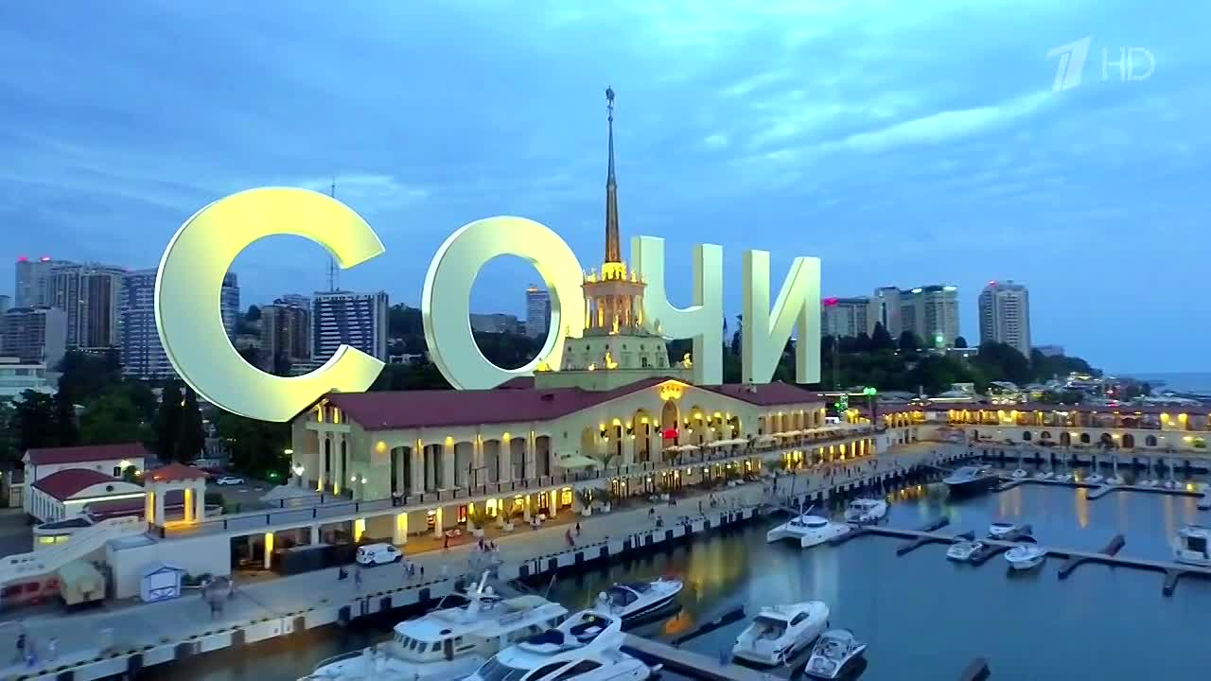  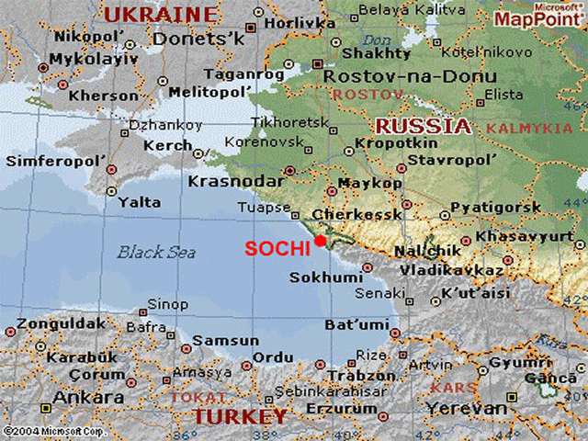  - Sochi is a popular Russian holiday resort the Black Sea coast | - The city is famous of its warm weather beautiful landscape golden beaches the resort and health spas  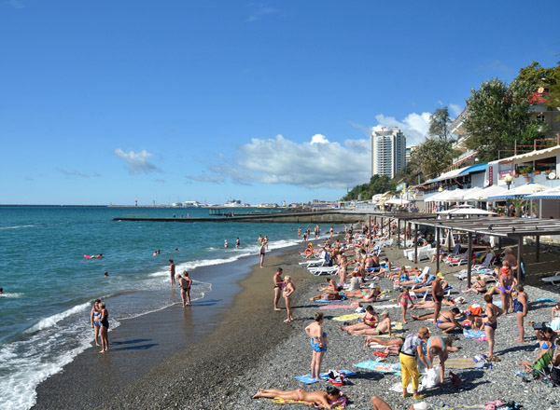
- Every summer more than 1,5 million visitors from Russia and abroad  - Sochi is a city that has got something to offer every one  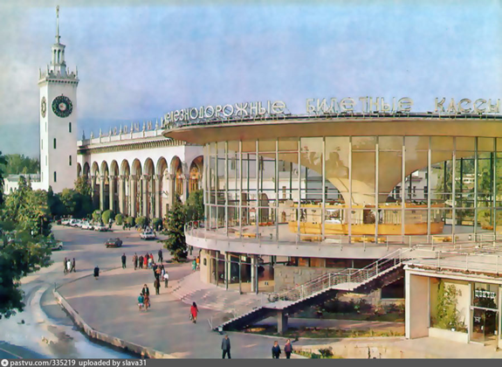 | - It has got an international airport  - It is about 1, 500 miles south of Moscow  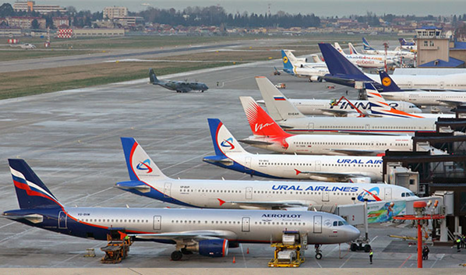 | - Skiing  - Hunting  - Fishing  - Mountain climbing  